**Backend Testing Result**

1. **Send Otp :-**

**Route :- /api/v1/sendOtp**

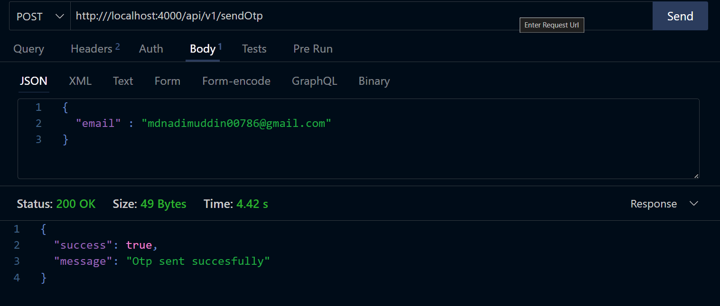

**Otp Sent on userMail**

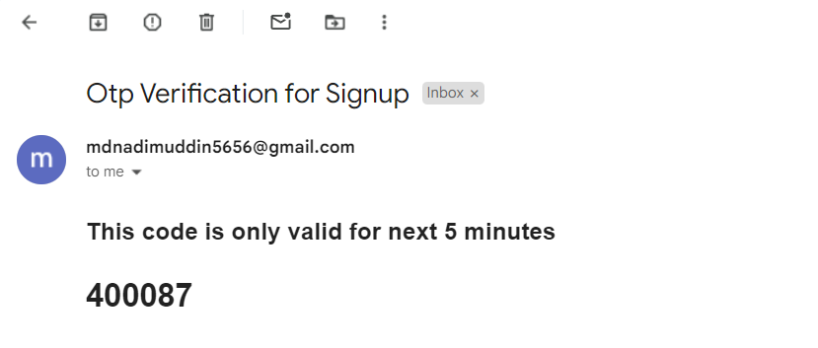

1. **Sign Up :-**

Route :- /api/v1/signup

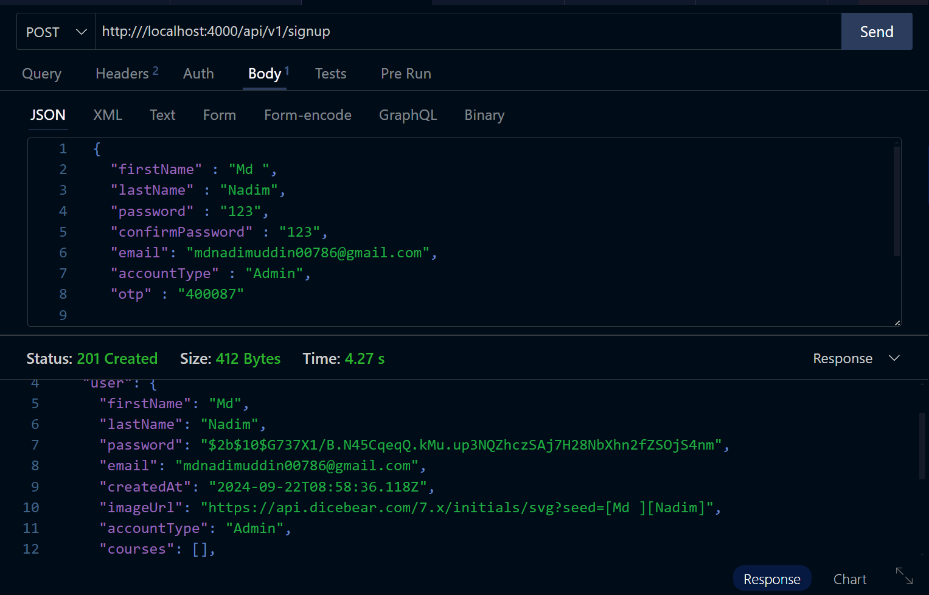

**A Mail is sent to user email after succesfully signup**

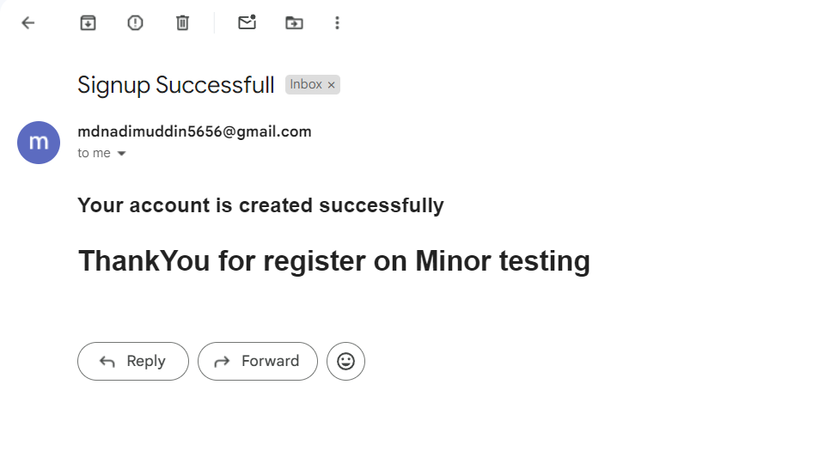

1. **Login**

Route :- /api/v1/login

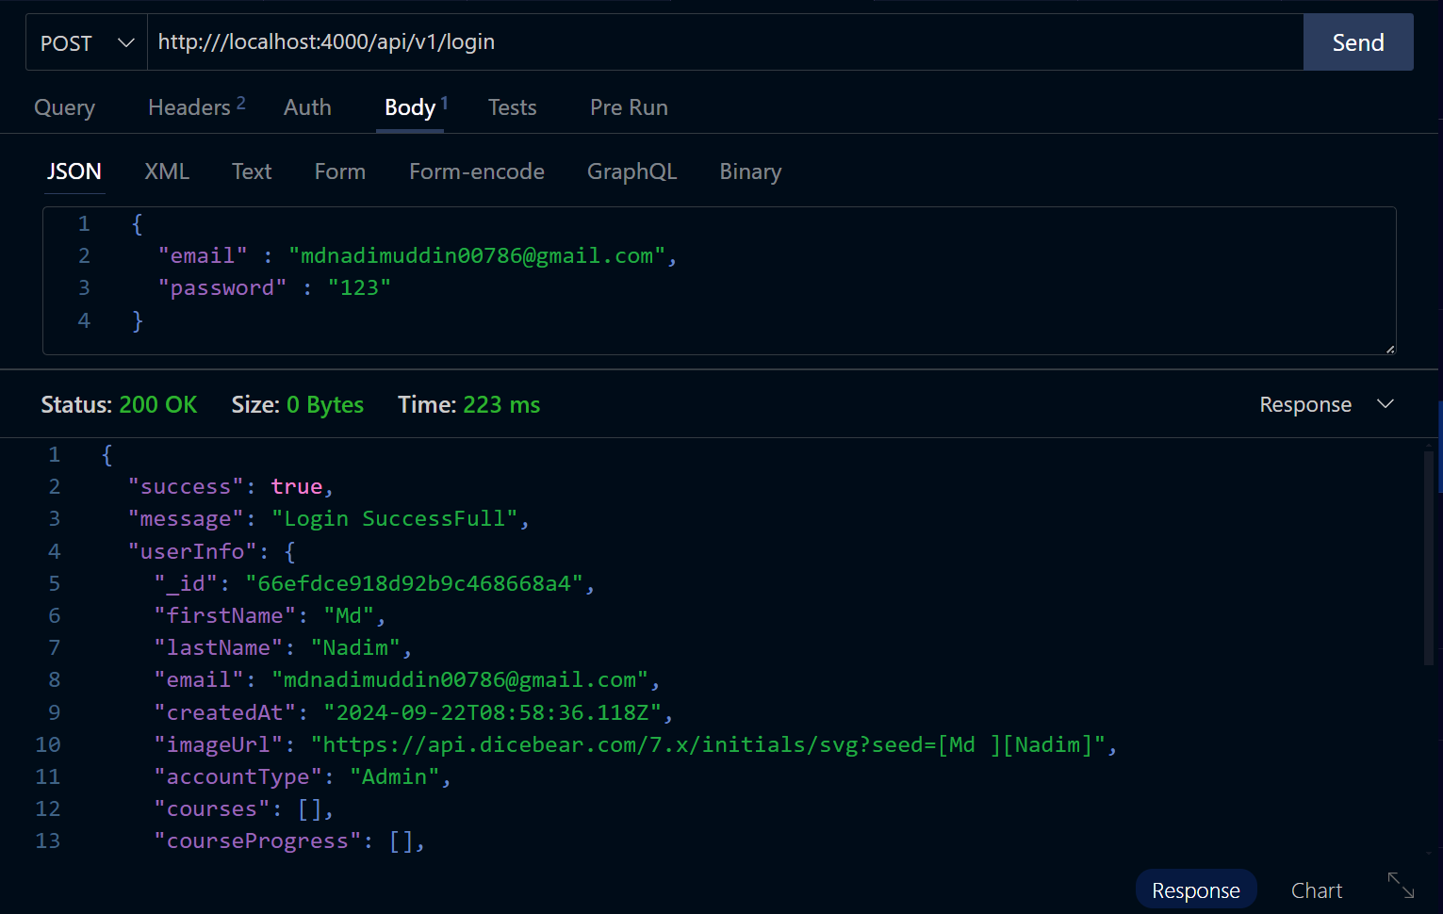

1. **Create Tag :-**

**Route :- /api/v1/createTag**

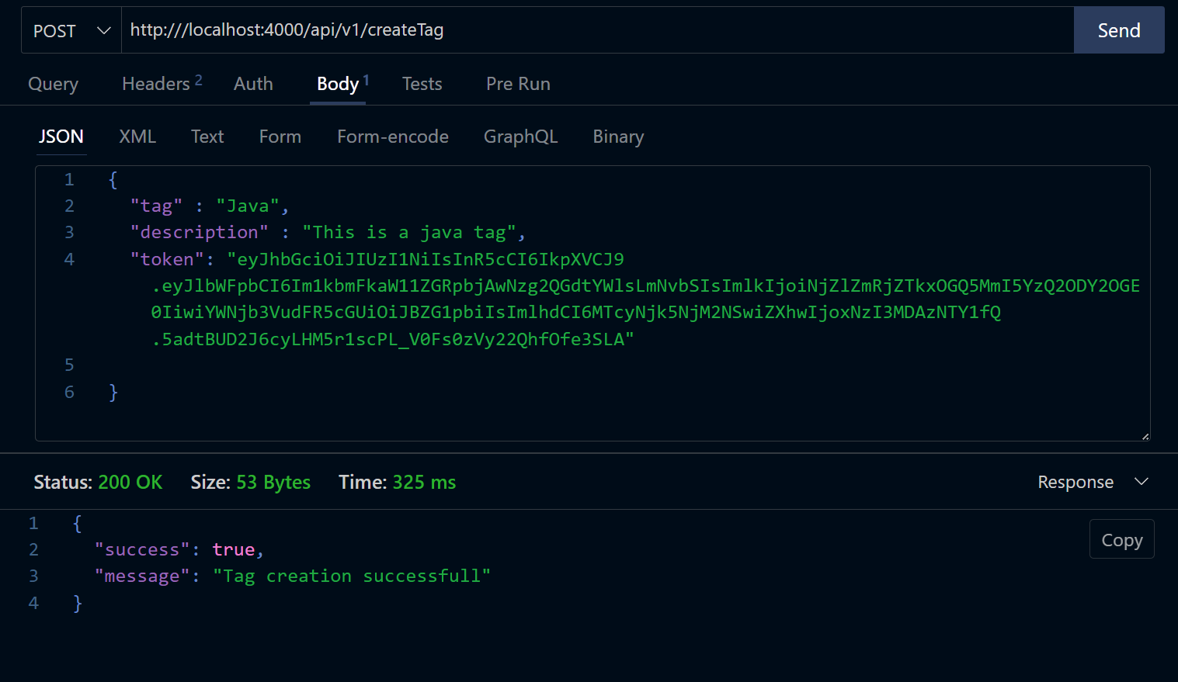

1. **Get All Tags :-**

**Route:- /api/v1/allTags**

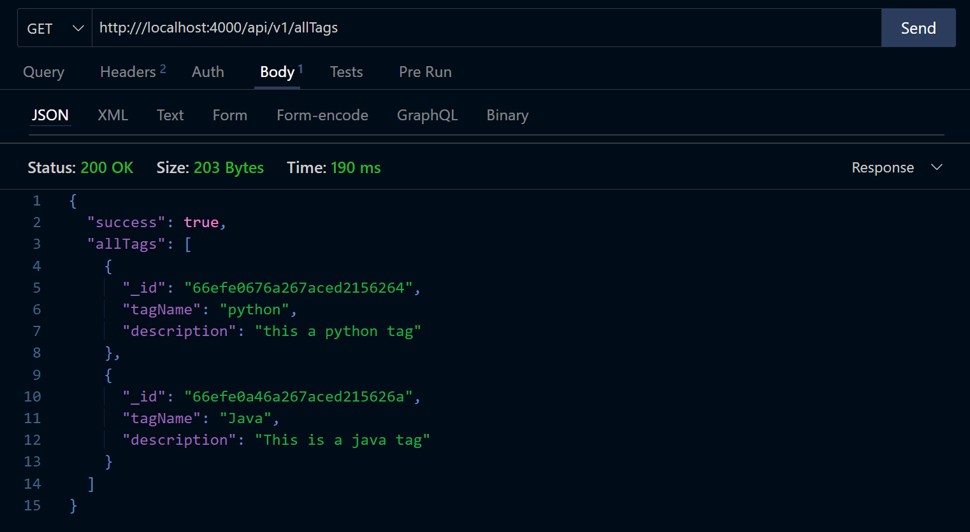

1. **Create Course :-**

**Route :- /api/v1/createCourse**

